After I decided to recreate a classic arcade game for my dissertation - I started the project by consuming articles discussing general video game development. This research prior to the practical development of the project gave me time to create, develop and establish ideas.

Articles generally refer to sizeable video game companies such as Rockstar or Activision and how they have a ‘pipeline’ for organising the flow of work. The ‘pipeline’ generally refers the process at a whole of developing a complete video game. I noticed this process remains unchanged throughout the articles I selected.

One article by Nadia Stefyn stated that **[1]** “*the pipeline is not necessarily a linear process*”. What I believe Stefyn means by this is that projects, especially relating to game development, continuously change throughout the development cycle. Furthermore, once an idea is established, such as mine, factors such as functionality and design change for the better during development.

Researching articles helped me establish a solid plan of development which I aim to slowly illustrate through project planning software such as Jira. In my case I feel this is detrimental for the success of my project. For instance, most projects consist of several people that confer and collaborate, whereas this is an individual project for me, so in order to stay on plan and to manage my time appropriately I have noted I need to put forward *‘issues’* on Jira which I can then use to refer to throughout my project.

Documentation is one of the most important parts of game development. This includes the project planning as I’ve discussed, but also often game design documents (GDD)’s. These game design documents essentially map out the design of the game. After creating one of these documents personally as coursework for a previous module I have developed a good understanding of the purpose of these documents. As Stefyn quoted in her article **[1]** “*A Game Design Document is essentially the game's north star. It’s a living document which helps everyone understand and get on board with the greater vision of the project.*” I feel that this summarises the significance of planning. Stefyn means that once a project is laid out in black and white, we have an easier time comprehending what needs to be completed.

Upon expanding on my idea through analysing my research articles I had created a mind-map of all the existing functionalities I thought of which I aim to implement into my project. I found this extremely useful as I actively refer and continuously add ideas. As evident in figure **[2]** I have expanded some of my ideas presenting where I aim to take them.

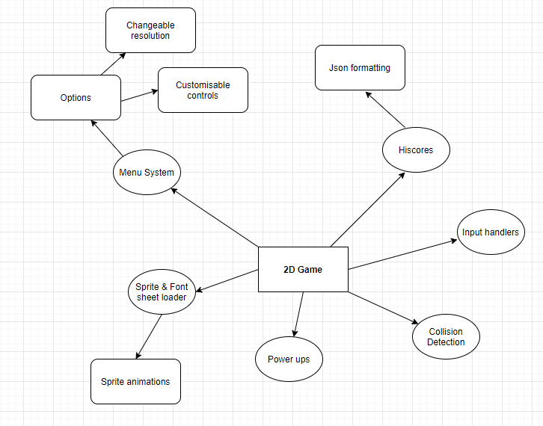

This brings me to the next part of my background research; this part revolves around the technical side aspect of the project. This is type of research is practical based and provides me with solid sources to reference back to throughout the development stage.

A large part of my research and background reading was based around the technical side of the project relating to Java and how I would begin to develop the game application. Throughout my previous years at university I have spent a significant portion developing games for various modules. I feel from this I can understand to a significant degree what is required in order to achieve my set goals - which can be found on Jira.

In figure **[3]** I have illustrated a game from one of my modules last year. The purpose of this game was to gather understanding and knowledge on how to paint and maneuver objects within Java – this knowledge is applicable for my project. The player object is controlled through keyboard controls using a basic key manager implementing Java’s default Key Listener. Furthermore, I had randomly generated enemy objects, assigned them with a Y-velocity for movement and then spawned them off-screen.

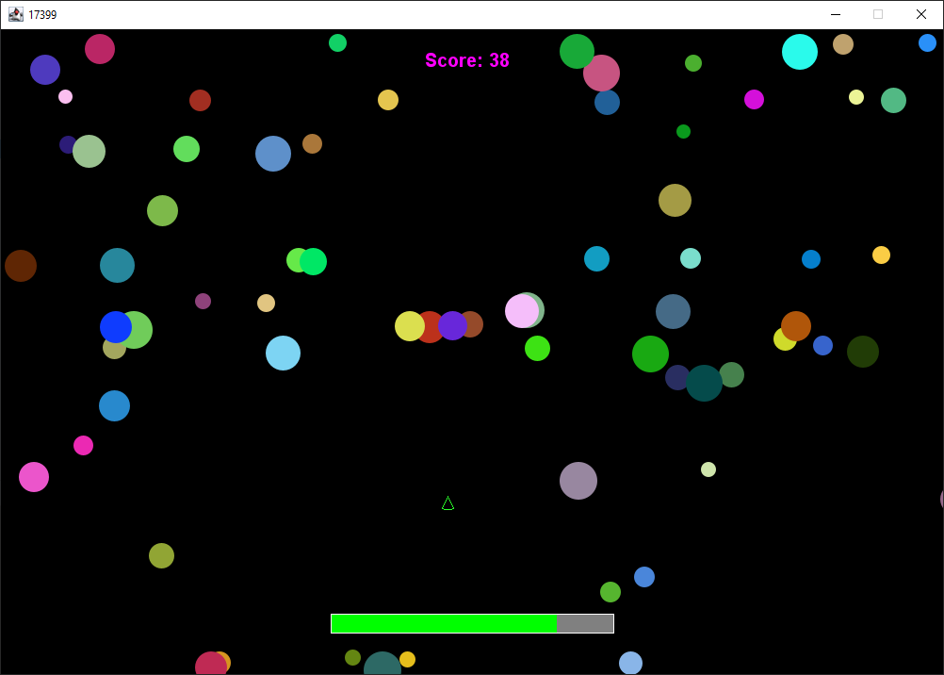

Additionality I had created another game throughout second year as part of one of my chosen modules. I found this game to be a huge improvement over my initial game project. This game had a lot more features packed into it including a menu system, high scores, and a custom font and sprite loader. I have included this as part of my background research for several reasons. One reason is as it helped me considerably get back to the understanding of Java programming. The most significant reason was that a lot of the features I plan to add to my Capstone Project I have already coded previously. Looking over these projects and noticing the improvements from the initial game to the one presented in figure **[4]** helps me now understand the future improvements I need to make in order to create a successful project.

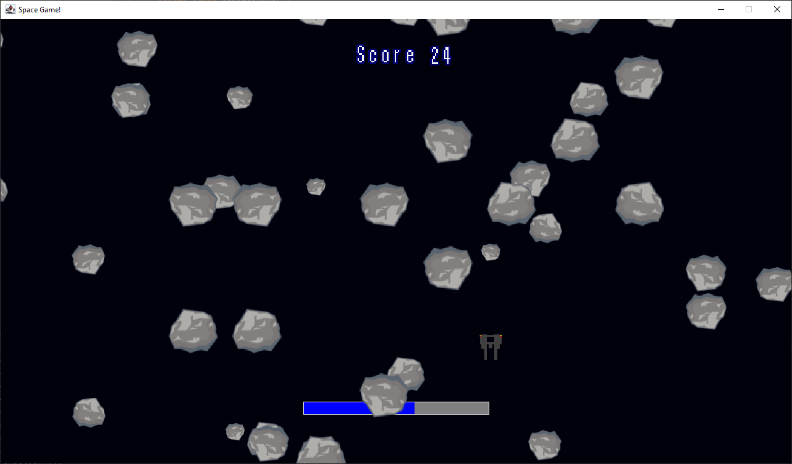

One issue that has remained consistent throughout the gave development history I have is collision detection. I found that I struggled with creating suffice object interaction throughout the projects which can lead to the game feeling ‘buggy’. Throughout my extensive background reading one important source I found was a website aimed at intermediate programmers **[5]**. This website discusses and teaches general practices needed for 2d game developers. The author(s) illustrate how they decided to program collision detection within their application. They break down the tutorial discussing various methods they implemented or used from Java’s Swing library. When I approach the stage of collision development throughout in my project, I will refer to this source to make possible improvements or changes.

**References**

**[1] -** [CG Spectrum: How Video Games Are Made: The Game Development Process](https://www.cgspectrum.com/blog/game-development-process)

**[2] -**

**[3] -**

**[4] -**

**[5] -** [ZetCode: Java 2D Games Tutorial](http://zetcode.com/javagames/)